Ionoregulatory Responses to OA figures

This is a place to paste the figures but they should also be saved in a folder as PDF files.

PDFs are saved in Github folder MenidiaOA>Ionocytes>Figures.

Embryos

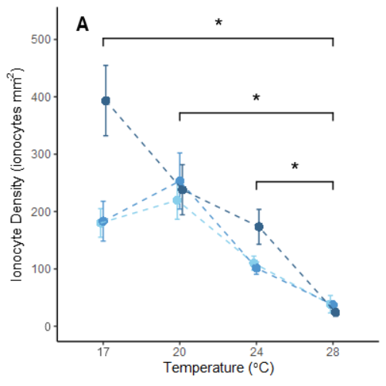 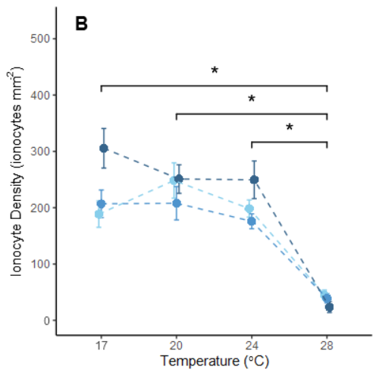

Figures 2A and 2B

Copied to clipboard with dimensions of 400x400.

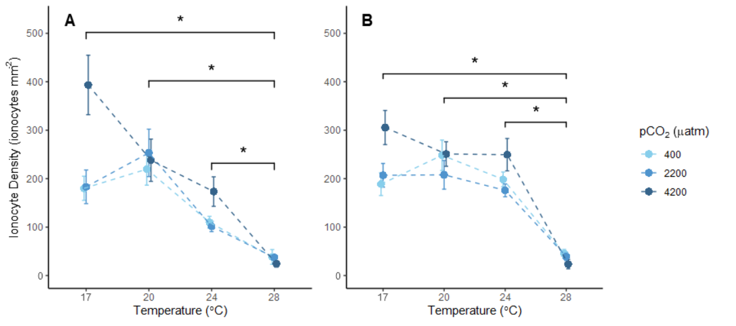

Figure 2

Copied to clipboard with dimensions of 900x400.

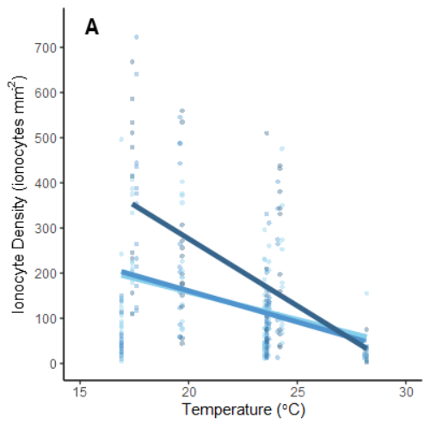 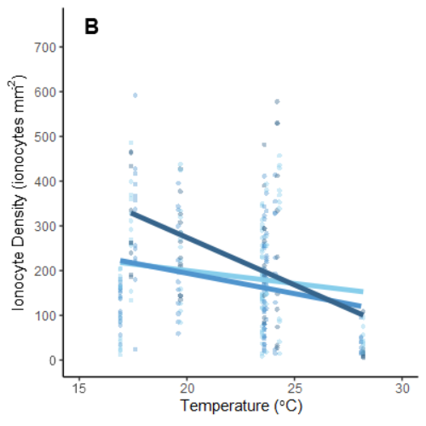

Figures 2A and 2B (alt)

Copied to clipboard with dimensions of 400x400.

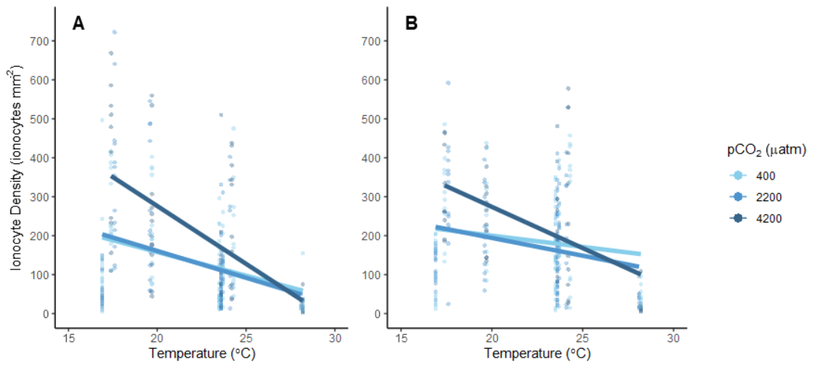

Figure 2 (alt)

Copied to clipboard with dimensions of 900x400.

Newly hatched and 10-mm larvae

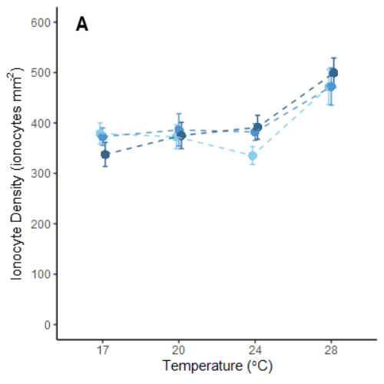 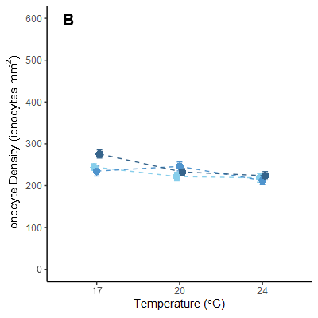

Figures 3A and 3B

Copied to clipboard with dimensions of 400x400.

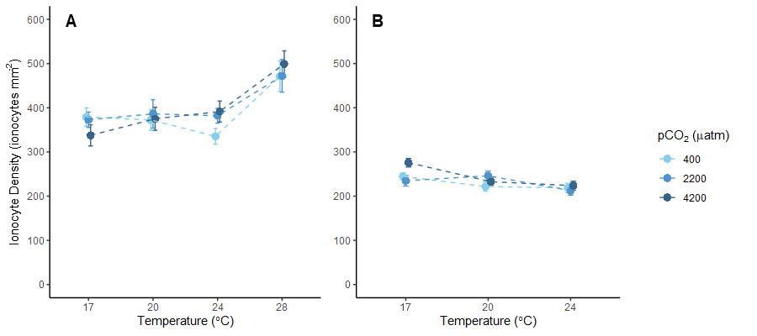

Figure 3

Copied to clipboard with dimensions of 900x400.

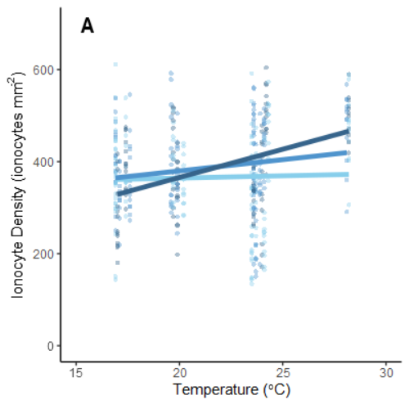 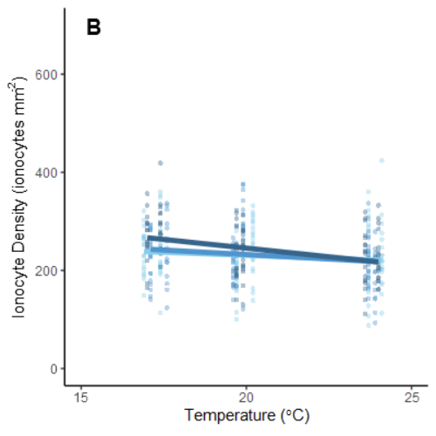

Figures 3A and 3B (alt)

Copied to clipboard with dimensions of 400x400.

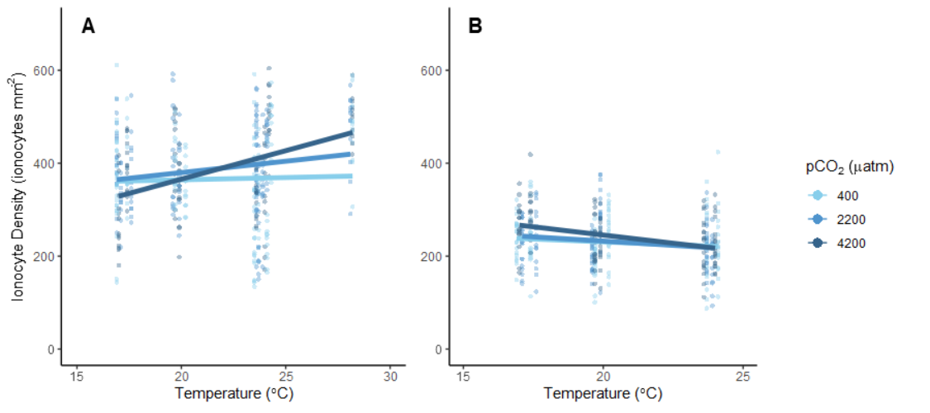

Figure 3 (alt)

Copied to clipboard with dimensions of 900x400.